

**Software Engineering and Testing. BSC Year 2, 2024/2025**

**Assessment 4: Software Testing**

**Submitted by:**

**B00160049 Matthew Keenan**

**B00159340 Stanislav Kolev**

**B0016388 Fabio Melilo**

**Submission date**

**24/3/25**

**Declaration**

I herby certify that this material, which I now submit for assessment on the programme of study leading to the award of Ordinary Degree in Computing in the Institute of Technology Blanchardstown, is entirely my own work except where otherwise stated.

Author: B00160049 Matthew Keenan Dated: 24/3/25

Author: **B00159340 Stanislav Kolev** Dated: 24/3/25

Author: **B0016388 Fabio Melilo** Dated: 24/3/25

**Table of Contents**

Project Definition Pg 4-5

Document Revision Pg 5

Methodology Pg 5-6

Requirements Pg. 7-9

Case Diagrams Pg. 10-14

Conclusion Pg 15-16

Unit Testing

**User (getter/setters)**

In user class test we take the getUsername and setUsername methods by creating an array of usernames and then in a for each loop creating a new user and setting their username as the same spot in the array

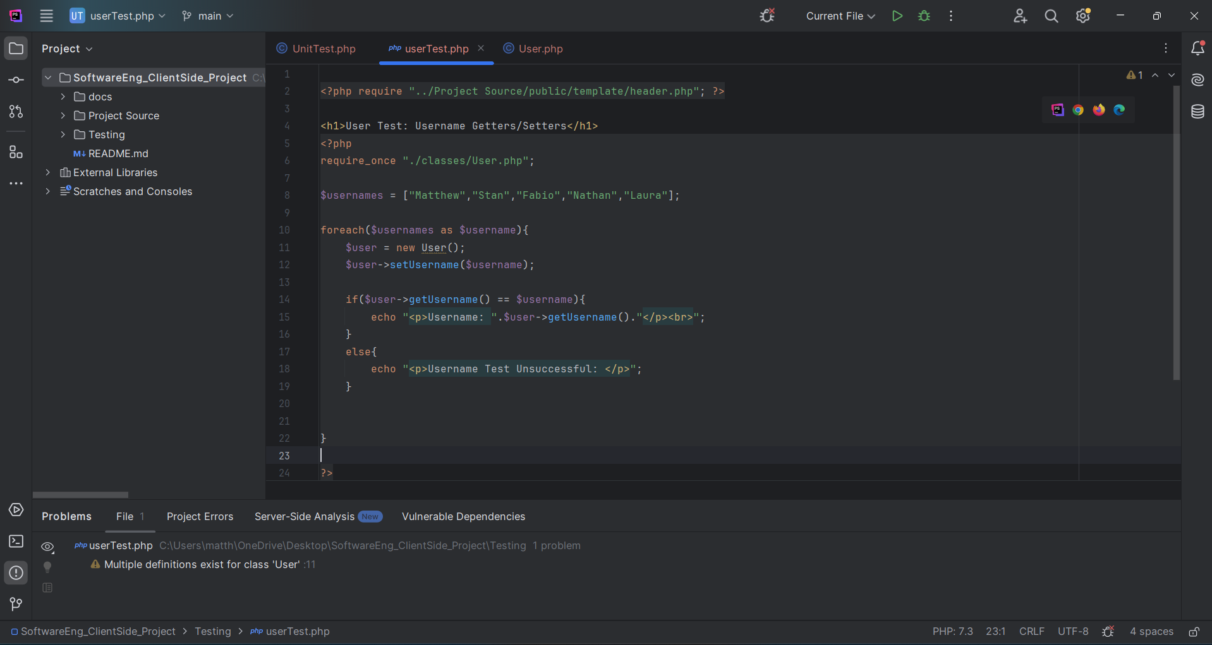

And we show it working in the browser like this:

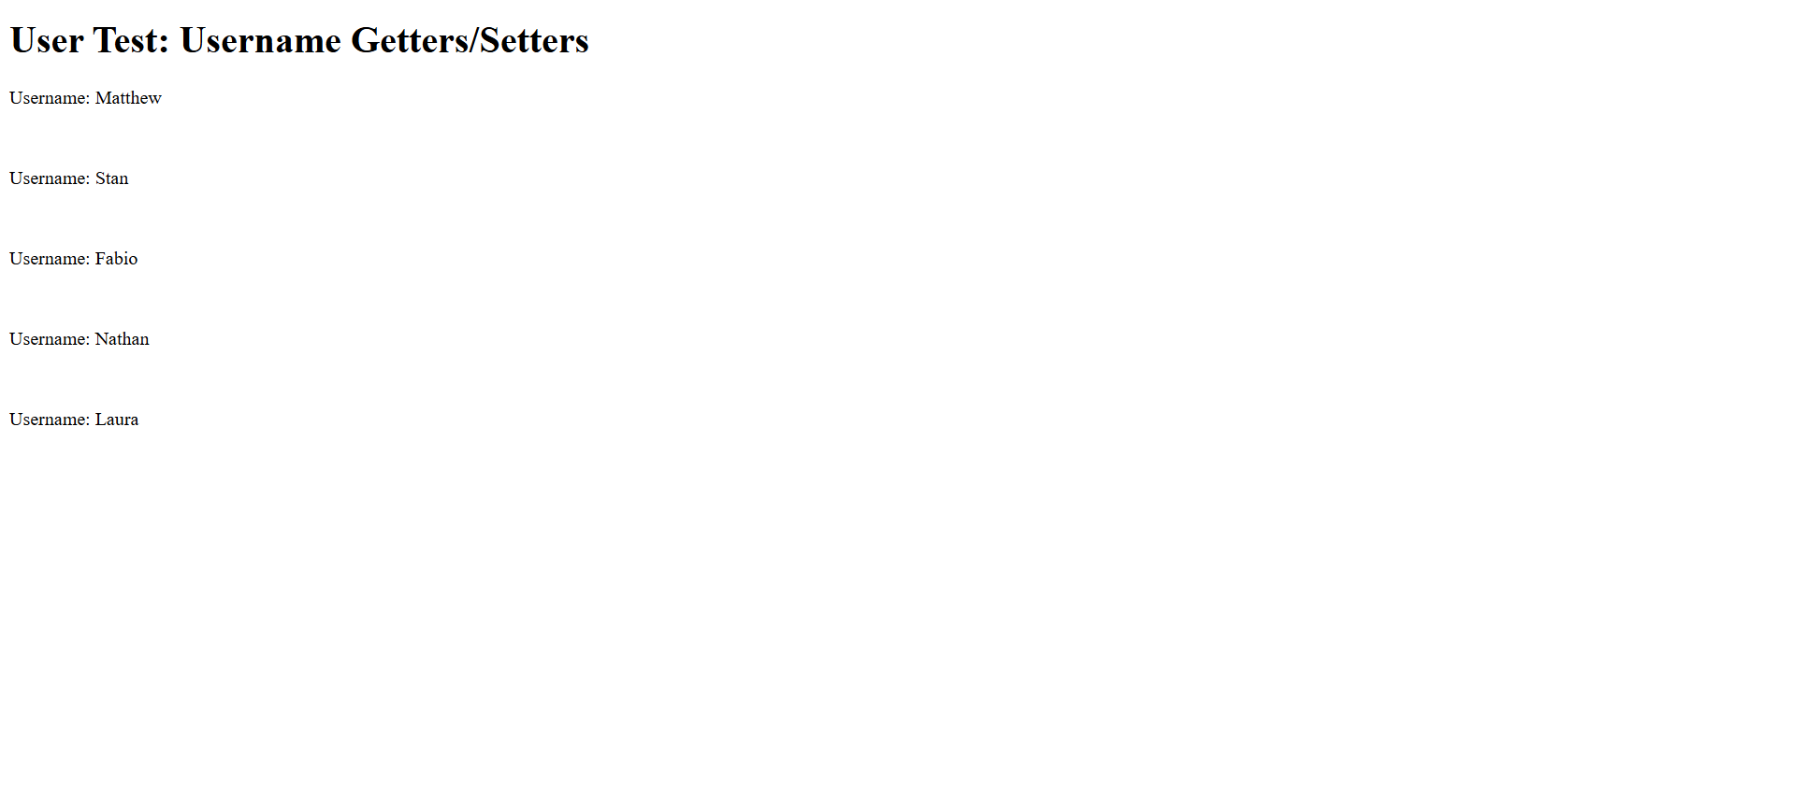

**Movie**

For the movie test the method fetchAllMovies and this is done by connecting to the database checks if the data is received and then they are displayed

**Booking**